Barmoor 1982 Trust
Interim BACKGROUND INFORMATION FOR YOUR HEALTH AND SAFETY ASSESSMENT
​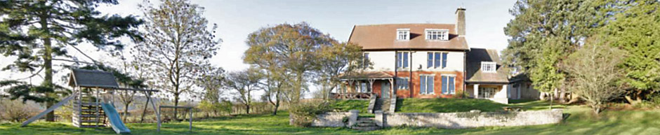
Barmoor is used by groups with a wide variety of wishes, needs and capabilities. The building and grounds are preserved essentially to the pattern of an Arts and Crafts House as designed in 1908. This means that aspects may be less convenient for modern living and may not be suitable for people with some particular requirements. It has not been felt appropriate or possible to make adaptations to cater for all possible needs, without completely changing the house that people love to visit. There will therefore be some potential users for whom Barmoor is not suitable and others who will need assistance or to take special care.

The Barmoor Trustees expect a group leader to make a Health and Safety Assessment for the needs of their group before making a booking.
A visit to check any aspect prior to booking can be arranged through the booking’s secretary.

The Trustees wish Barmoor to be safe for all users and would like you to know that they fulfil their responsibilities to that effect.

- A professional inspection of the fabric of the building on a 5-yearly cycle ensures that we do not miss anything in our maintenance scheme.
- The fire alarm, fire extinguishers and emergency lighting are professionally inspected and serviced annually. They are checked before each letting period.
- Fire doors have closers and intumescent paint to reduce spread of flames and smoke.
- All windows are restricted to not more than 100mm opening.
- The electric circuitry is professionally checked 5-yearly.
- All Portable Electric Appliances are professionally tested annually.
- The boiler and gas cooker are professionally inspected and serviced annually.
- There are carbon monoxide detectors in all rooms with combustion appliances, which are checked for function before each letting.
- Chimneys are swept annually.
- The water supply and storage system has been altered to minimise the chance of growth of the Legionella organism. Hot and cold water temperatures at sentinel taps are monitored weekly. Non-drinking water taps are marked.

Listed below are some areas you might consider, obvious or less obvious, when making the risk assessment for your group and thinking how to minimise your risk, without removing the benefits of a visit to Barmoor.

The safety of Barmoor depends on its users treating it well, and promptly reporting any breakages or faults that are noticed.

Please let us know if you think anything else should be added to this document via Contact Us.

In the house

Smoking is not allowed and is indeed illegal anywhere within the building.

Fires
There are open fires in the Living Room and Quiet Room, burning wood and/or coal. Fires should be kept to a sensible size and guarded at all times.

Stairs
The back stairs in the house are steep.
The fire-exit stairway for the second floor is particularly so and should not be used in any other circumstance.

Door closers
The powerful door closers for the heavy doors are necessary for fire protection. They can be difficult to open for the very young or weak and might close unexpectedly on unsupervised toddlers.

Furniture
Some furniture in the house is original and vulnerable to misuse. Treat it with due respect.

Kitchen equipment
The kitchen equipment is of domestic origin and should be generally familiar to users. Be aware that larger pans may be heavier than those at home.

Water temperature
Note that the hot water temperature is high to prevent growth of Legionella.

Coronavirus
Each group is responsible for precautions against Covid-19 during their stay. It is recommended you follow government advice as from time to time issued.
Some guidance is offered by Barmoor Trustees at <Link>
Up to date and detailed advice from government is at https://www.gov.uk/coronavirus

In the Harvey Room

Closed stove
The closed stove is for wood burning only. It is important to follow the instructions provided. It should NOT be used with the doors open, when it would be less efficient and with increased fire risk. The fire guard should be used at all times.

Furniture
The folding tables are heavy and best managed by two people. Carefully follow the instructions for assembly. The stacking chairs can go on their trolley if moved carefully. Follow instructions to set up the table tennis table.

In the grounds

The site is sloping with a steep bank in front of the house that is not fenced from the walkway in front of the house. The upper lawn has a retaining wall with a drop on the lower side. The short runs of steps do not have handrails.

The lawns are maintained in a rough condition and mowed through the season, with rough edges which include some areas of stinging nettles.

The only outdoor fires permitted are disposable barbecue sets only on the area provided. They should be fully extinguished after use. No fire should be lit on the grass, and fires are not allowed on the moor.
The cellar of the house is not in use and is locked. The steps to the cellar are steep and very slippery; the gate at the top is locked. It should not be used or played with.

Play equipment
The swing/slide/climbing frame is appropriate to children below secondary school age. Older children need to play responsibly, particularly in mixed-age groups.

Ball games should be on the lower lawn. The balls and mallets of croquet and the balls of bowls are heavy and might lead to injury if play is careless, or for young children who might enter the field of play.

The tyre swing is a great favourite of many children and we would not wish to forbid it them. We recognise that that it is a particular hazard for young children of toddler age who have yet to learn the way swinging objects come back. If your group contains such, consider how you will supervise their play or forbid its use. The tyre could be tied back to the tree trunk with the rope provided to make it unusable.

The two fields below Barmoor are let to a local farmer. Our private footpath, which groups may use, runs down the eastern edge. If animals are present, they are not expected to offer risk, though young cattle may be inquisitive. If they approach it is best to stand still and let them say hello. If you have a frightened dog with you, it is best to let the dog run free.

On the Moor

All the unfenced land outside Barmoor is ‘Access Land’, meaning that anyone can go anywhere. It is however still privately owned and farmed, in particular for sheep and grouse. In spring there are young lambs and in summer ground-nesting birds. Dogs should be on leads throughout that time. A dog owner could be liable for the cost of damage from worrying sheep, and in extreme cases a farmer may legitimately shoot an offending dog.

Be aware that the vegetation, particularly the bracken, grows high in late summer, and may conceal holes or obstacles. Take care; it may be wisest to keep to paths.

Shooting.
The grouse shooting season is between August 12th and December 10th. Teams of beaters drive birds toward a line of guns who hide behind the heather-covered butts. There are none of these immediately near Barmoor. There are a lot of people in this activity, which will be obvious and is well stewarded. Rights-of-way remain open, but areas of Access may be temporarily closed.

Pheasants, and to a lesser extent partridges, are bred for shooting during the winter months in the farmland and woodland areas. There are smaller numbers of guns, usually on private land, and again avoiding rights of way.

All shooters have a duty of care to the public, but may get understandably annoyed if their activities are disrupted.

The moor to the east of Barmoor was used for live-firing training during the Second World War and was never officially cleared. We are not aware of any accidents, but no one should handle strange or metal objects found on the moor.

The Nab (the hill to the west of Barmoor) has been used, and may be used again, for Clay Pigeon shooting. This is target practice of black plastic ‘clays’ fired off the top of the nab. You may find fragments scattered on the moor, or intact 8cm discs that were missed. They are harmless.

Lyme Disease is a rare bacterial infection spread to humans by infected ticks, and the North Yorkshire Moors is an area with a high population of ticks.
Ticks are tiny spider-like creatures found in woodland and heath areas. They feed on the blood of birds and mammals, including humans and dogs. They can be found in any areas where there is deep or overgrown vegetation and where there is access to animals for them to feed on. Ticks climb onto your skin or clothes if you brush against something that they are on. They then bite into the skin and start to feed on your blood. Left to themselves they would drop off when finished.
There are many ways of reducing the risk of getting bitten. Keep to designated footpaths, and wear lighter coloured clothing as the ticks will then be more visible. Keep any dogs on a lead. Check your skin, and particularly that of children, when you get back from a walk through vegetation.
Ticks are very small and their bites are not particularly painful, so you may not realise you have one attached to your skin. It is thought that only a small proportion of ticks carry the bacteria that cause Lyme disease, so most tick bites do not lead to infection. Generally, an infection is more likely if the tick remains attached to your skin for more than 24 hours.

However, it is important to be aware of the risk and seek medical advice if you start to feel unwell. A first pointer may be flu-like symptoms and/or a persisting target-like rash at the site of the bite some weeks after the bite. Lyme disease can usually be treated effectively if it is detected early, but if treatment is delayed there is a risk of severe and long-lasting symptoms. More information is at https://www.nhs.uk/conditions/Lyme-disease/ .
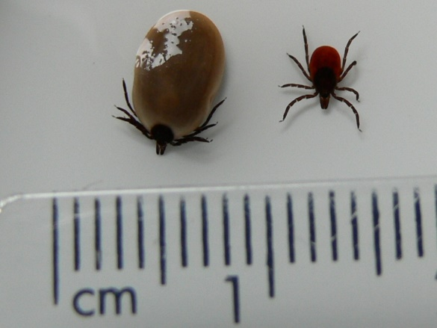
This image shows the engorged tick after feeding, and also as it is before feeding.

To remove a tick safely:
- Use fine-tipped tweezers or a tick-removal tool which you can buy from some pharmacies, vets and pet shops. [Some will be available in the Barmoor First Aid box].
- Grasp the tick as close to the skin as possible.
- Steadily pull upwards until the tick lets go, taking care not to squeeze or crush the tick. Dispose of it when you have removed it.
- Clean the bite with soap and water or antiseptic.
- If mouthparts are left in the skin, just leave them to come away in their own time.

- DO NOT squeeze the body of the tick, as this may leave the head stuck in your skin.
- DO NOT use your fingernails to remove a tick. Infection could get under your fingernail.
- DO NOT crush the tick’s body.
- DO NOT try to burn the tick off, apply petroleum jelly, nail polish or any other chemical.
Any of these may cause it to regurgitate its infected stomach contents into the bite wound.

The risk of getting ill is low. You do not need to do anything else unless you become unwell.

IN EMERGENCY

A simple first aid kit is kept in the kitchen. Please report any use.
For NHS Urgent advice service Dial 111
If you have a mobile phone and a signal, NHS 111 Online may be quicker
Doctors practice at
The Kirkbymoorside Surgery, Tinley Garth, Kirkbymoorside, YO62 6AR
Tel: 01751 431254 Mon – Fri 8.00 – 18.00 Not Public holidays.
Since Covid-19 all consultations start with a phone-back or smartphone call.
Out of hours service-base in Malton and Scarborough via this number or 111.

Accident and Emergency departments are at
York Hospital, Wiggington Road, York YO31 8HE; Tel: 01904 631313
Scarborough General Hospital, Woodlands Drive, Scarborough YO12 6QL; Tel: 01723 368111
The Friarage Hospital, Northallerton DL6 1JG; Tel: 01609 779911

Emergency Ambulance Dial 999

Dentist
Alpha Dental, 37 West End, Kirkbymoorside, YO62 6AD
Tel: 01751 432 418 or 111. Mon – Fri 8.30 – 17.30 Not Public holidays.

Veterinary Surgeon
Grace Lane Veterinary Surgery, Weighbridge Close Kirkbymoorside, York YO62 6FD
Tel: 01751 432777 Mon – Fri 8.30 – 18.30

Fire
In the event of fire your priority should always be to evacuate the building. The assembly point is on the lower lawn.
Dial 999 for Fire & Rescue Service from the house phone, a mobile phone or next door.
- The address is Barmoor, Huttonlehole, Kirkbymoorside, North Yorkshire YO62 6UE.
The fire alarm will be triggered by smoke, or manually at the break-glass points by all exits.
Appropriate fire extinguishers are throughout the building with a fire blanket in the kitchen. Only tackle a fire if it is small, and safe to do so.
- If your group includes younger or older people or those with disabilities who might have difficulty getting out, consider how you will assist them.
- Might there be difference for a fire in the day-time or the night-time?
- If individual parties of your group leave the premises during a day, how will you know they are away and not trapped in the building?
The trustees strongly recommend that each group holds a fire practice soon after their arrival to familiarise themselves with procedure and spot any problems.

Instructions for fire alarm practice are by the panel in the kitchen.

