Barmoor 1982 Trust
Your Risk Assessment for Covid and other infectious disease at Barmoor
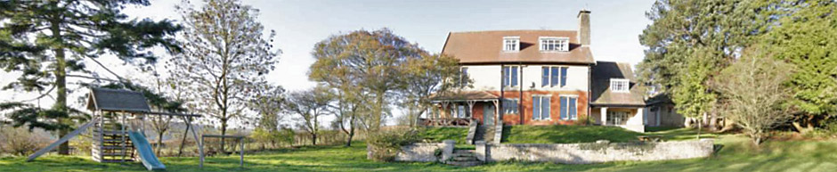
The impact of Covid-19 has reduced since the early days of the pandemic. Its risk should now be considered in the same way as other respiratory, as well as non-respiratory infections such as norovirus winter vomiting disease. We are using the term virus to cover all of them in this document.

Spread may be by droplets in the air or picked up from surfaces that have become contaminated. Risk is inevitably greater at Barmoor than in your own home, because individuals come together from different places, and it needs to be managed accordingly.

Risk of contracting infection at Barmoor comes from a combination of [1] any chance of residual virus in the house from a previous letting, [2] chance of introduction of virus by the current users, and [3] risk of then spreading virus between occupants. It is increased when there is a lot of virus about in the community or if people come from high-risk areas, and by the closeness and duration of contact with an infected person, even when they have no symptom. Vaccinations may greatly help but do not give complete protection to everyone.

The big part of managing risk lies in the behaviour of the occupants and is not in the control of the Trustees.

We therefore expect each group to make its own specific Risk Assessment prior to their visit, and to explain and communicate to their group.

What we have done to manage risk:
- Eliminating any residual virus
The house will have been cleaned to a domestic standard before each letting, followed by specific anti-viral disinfection focussed on frequent-contact areas such as doorhandles and push plates, light switches, bannisters and chairbacks and surfaces in kitchens and bathrooms.
- Preventing introduction of virus
Soap and paper towels [best], or alcohol gel are provided. These are effective ways of decontaminating hands, for use on entry and throughout your stay.
- Preventing spread of any virus
The mantra of Hands-Face-Space-Fresh Air applies. All rooms have at least one opening window. We have outdoor picnic tables and various undercover outdoor park benches and seating options, which facilitate activity outdoors.
Consider at least a twice daily clean as in [1] above, and with handwashing before meals or cooking.
Residual risks
Crockery and kitchen equipment will be left as cleaned by the previous occupant. We expect it will have passed through hot soapy water to be clean. Feel free to re-wash to your own standard should you so wish.
We have not disinfected any outdoor items or play equipment. Likewise, the Harvey Room is presented as a cleaned empty space. The furniture and equipment have not been specifically cleaned, which you may undertake should you need to.
Materials are provided for you to do any more intensive cleaning yourself should it seem appropriate to the needs of your group.
January 2023

