Barmoor 1982 Trust
ACCESSIBILITY
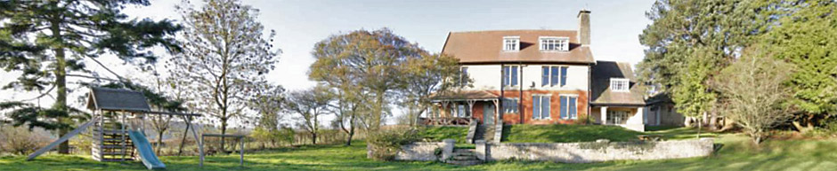
​When Barmoor was built, little thought was given to meeting people's varying needs. Bearing in mind its historical importance, the trustees have the view that we should limit alteration that would significantly alter the ambience that is so valued.
With this in mind
​These features may assist access.
- ​There is step free access to the key rooms of the ground floor.
- There is a low step to the Harvey Room. A ramp is available.
- Doorways are wide enough for wheelchair use.
- There is a wheelchair-accessible toilet by the back door with walk-in shower.
- There is a high toilet with grab handle and frame by the front door.
- There is an accessible toilet in the Harvey Room.
- The narrow back stairs have a double handrail.
- The wide front stairs permit an accompanying assistant.

These are features that may restrict access.
- ​Doors have powerful closers [to limit spread of fire] that would prevent unassisted wheelchair use.
- There are no beds on the ground floor.
- There is a ten-inch step-over sill to the second floor bathroom.
- Illumination in some areas is limited.
- Light switches are not at low level.
- There is no hearing loop.
- The car-park area is tarred but not level.
- The garden is maintained in rough condition on a sloping site.
​
The trustees would be pleased to hear [via 'Contact Us'] from users or potential users of any problems they have met, with possible practical solutions.

