Barmoor 1982 Trust

Safeguarding at Barmoor: A short guide
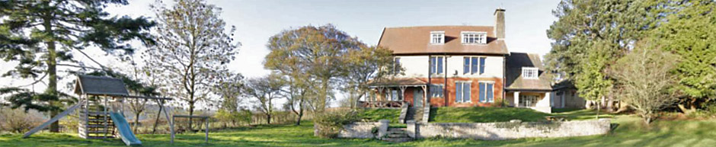

We talk of Safeguarding vulnerable people – be they adults or children – as the action we take to look after their welfare and protect them from harm.

Vulnerable people include
- all children below the age of 18 years. It is accepted that children gain maturity at different rates prior to age 18 and that some understanding of this is appropriate
- adults who need care because of disability, illness, age or social circumstance; and are or may be unable to protect themselves against significant harm or exploitation.

Harm might include maltreatment, such as physical abuse and illness, emotional or sexual abuse, and neglect (including trafficking and female genital mutilation) and besides deliberate evil, might result from
- parents’ or carers’ physical or mental ill-health
- domestic violence, alcohol or drug use
- risks associated with the internet and online social networking
and may be a harm experienced during their time at Barmoor, or elsewhere.

Safeguarding is everyone’s responsibility, and anyone who encounters vulnerable people and their families may have a role to play. Much is common-sense within our daily relationships with one another.

The variety of groups using Barmoor may include individuals with vulnerabilities of physical or mental health, personal life or social environment. All risks cannot and should not be avoided, but risks to individuals can be reduced by anticipation. The Barmoor Trustees wish to minimise risk related to the physical environment, but to preserve features of the site that make it unique.

Leaders of groups should consider these issues and have plans in place to manage them, depending on the nature of their group and its activities. We cannot overemphasise that new users should arrange with our bookings manager to visit Barmoor prior to their visit to make their own assessments and plans.

Sometimes the situation of a time at Barmoor could reveal an abuse or neglect of an individual in some other environment, for which safeguarding should be in place.

You have a responsibility to report this so that careful and objective assessment can be made. The responsible agency in the first instance is North Yorkshire Social Services.

Advice on how to proceed is always available from the duty Social Worker 01609 780780

[use the same number outside office hours for urgent matters].

Much further information is at www.northyorks.gov.uk/safeguarding

These are issues that many of us find challenging. But remember the quotation that
‘The only thing necessary for the triumph of evil is for good men to do nothing’.

Refer to our Background information for your health and safety assessment
or More detailed safeguarding guidance for further thoughts.

